EXPERIMENT-5
1. AIM:
To generate relational and multidimensional reports on the star schema developed in Experiment 3 and extended in Experiment 4, using table and matrix visuals, the Geo_Hierarchy, and comparative charts in Power BI, and to combine these reports into an interactive dashboard that supports business decision-making.

2. OBJECTIVE:
- To verify the existing star schema relationships and the Geo_Hierarchy in the Power BI data model.
- To create a relational report that displays individual business transactions using a Table visual.
- To create a multidimensional report using a Matrix visual and geographical drill-down operations.
- To build comparative charts for category, region, customer and yearly sales analysis.
- To design an interactive dashboard using KPI cards and slicers for business analysis.

3. TOOLS / SOFTWARE REQUIRED:
- Microsoft Power BI Desktop
- Global Superstore dataset and the Power BI (.pbix) file saved after Experiment 4
- Fact_Sales and dimension tables: Dim_Customer, Dim_Product, Dim_Region and Dim_Date
- Power BI Table, Matrix, Card, Slicer, Bar/Column, Donut and Line chart visuals

4. DATASET USED: Global Superstore Dataset.xlsx.
5. THEORY:
Business Intelligence (BI) reporting converts business data into meaningful information that helps organizations monitor performance and make decisions. A relational report presents individual transaction records in rows and columns, preserving the detailed information of each order. It is useful for checking a particular order, customer, product, sales amount or profit value. A multidimensional report, in contrast, summarizes data across dimensions such as region, state, city, product category and date. In Power BI, a Matrix visual can display these summaries and allow users to drill down or drill up through a hierarchy.
A star schema organizes analytical data into a central fact table connected to dimension tables. The Fact_Sales table stores measurable business transactions, while dimension tables provide descriptive details about customers, products, regions and dates. Measures such as Total Sales, Total Profit, Quantity and Total Orders summarize the fact data. Comparative charts make it easier to identify differences between categories, customers and regions, and to observe trends over time. An interactive dashboard combines KPI cards, charts and slicers so that users can filter several report visuals and explore business performance from different perspectives
6. PROCEDURE:

A. Starting Power BI and Preparing the Data Model
Step 1: Open Microsoft Power BI Desktop. Select File → Open Report and open the required Power BI (.pbix) file containing the Global Superstore dataset. If starting with a new report, import the required dataset using Home → Get Data.
Step 2: Open Model View and verify that the Fact_Sales table and four dimension tables are available:
- Dim_Customer
- Dim_Product
- Dim_Region
- Dim_Date
Step 3: Establish the relationships between Fact_Sales and the four dimension tables. Ensure that each relationship is configured as Many-to-One, with Fact_Sales on the Many side and the dimension table on the One side.
Step 4: Expand Dim_Region and create or verify the geographical hierarchy named Geo_Hierarchy. Arrange its fields in the following order:
- Region
- State
- City
Step 5: Switch to Report View and verify that the required fields and measures are available. Ensure that the existing data model is ready for report generation.

B. Creating the Relational Report
Step 6: Add a new report page by clicking the (+) button at the bottom of Power BI. Rename the page as Relational Report.

Step 7: Select the Table visual from the Visualizations pane and add the following fields in the specified order:
- Order ID from Fact_Sales
- Customer Name from Dim_Customer
- Product Name from Dim_Product
- Region from Dim_Region
- Sales from Fact_Sales
- Profit from Fact_Sales
Step 8: Select the Sales column header and sort the table in descending order so that the highest sales transaction appears at the top.
Step 9: Open the Filters pane and add Profit under Filters on this visual. Select Advanced Filtering, choose is greater than, enter 0 and apply the filter. This displays only the profitable transactions.
Step 10: Record the number of rows remaining after applying the Profit filter. Note the Customer Name and Product Name displayed in the first row.
Step 11: Right-click the table visual or select the three-dot menu. Choose Export data and save the table as an Excel or CSV file.

C. Creating the Multidimensional Report
Step 12: Add a new report page and rename it Matrix Report. Select the Matrix visual from the Visualizations pane.
Step 13: Drag Geo_Hierarchy from Dim_Region into the Rows field well.
Step 14: Add the following fields to the Values field well:
- Total Sales
- Total Profit
- Quantity
Step 15: Use the expand controls on the Matrix visual to drill down from Region to State and then to City.
Step 16: Use the drill-up arrow to return from City to State and then to Region.
Step 17: Select the same State used in the Drill page of Experiment 4. Compare the City-level Sales, Profit and Quantity values in the Matrix Report with the previously recorded values.
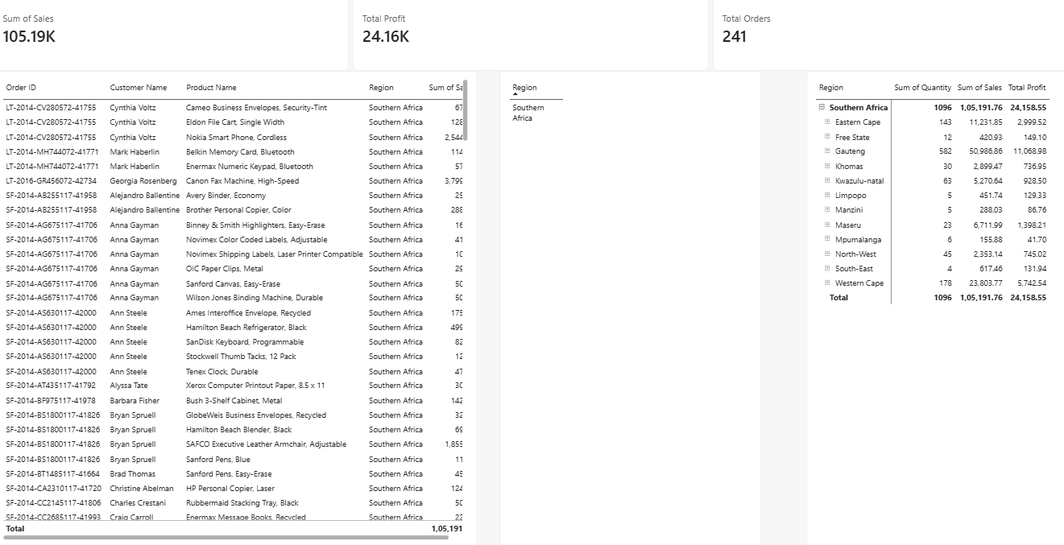

D. Creating the Comparative Analysis Report
Step 18: Add a new report page and rename it Comparative Analysis.
Step 19: Copy the Sales by Category chart and Profit by Region chart created in Experiment 3 onto this page. Alternatively, recreate the visuals using the appropriate fields.
Step 20: Create a bar chart to display the top ten customers according to their sales.
- Axis: Customer Name
- Values: Total Sales

Step 21: Create a Line Chart to analyse yearly sales performance.
- X-axis: Year from Dim_Date
- Y-axis: Total Sales

Step 22: Set the titles of all four visuals as follows:
- Sales by Category
- Profit by Region
- Top 10 Customers by Sales
- Sales Trend by Year

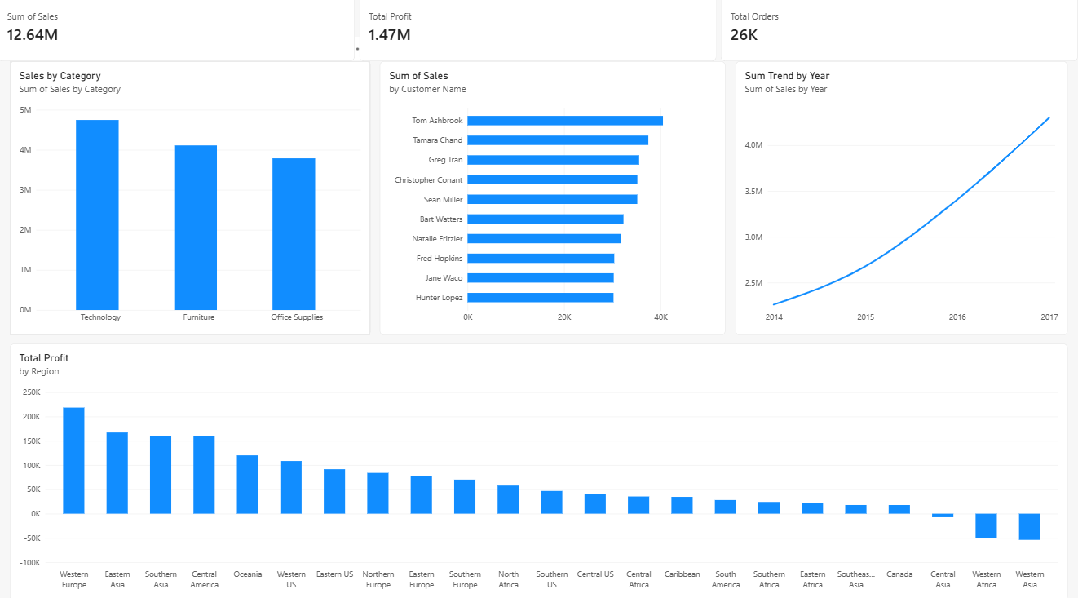

E. Creating the Interactive Dashboard
Step 23: Add a new report page and rename it Dashboard.

Step 24: Insert three Card visuals to display the following key performance indicators:
- Total Sales
- Total Profit
- Total Orders

Step 25: Add three Slicer visuals to enable interactive filtering of the dashboard.
- Region
- Category
- Year
Step 26: Add the required charts to the dashboard and arrange all visuals properly to create a clear and organized layout.
Step 27: Select the Format tab and enable Edit Interactions. Verify that the Region, Category and Year slicers filter all relevant charts and KPI cards.
Step 28: Test the dashboard by selecting different values in the slicers. Observe whether the cards and charts update according to the selected filters.

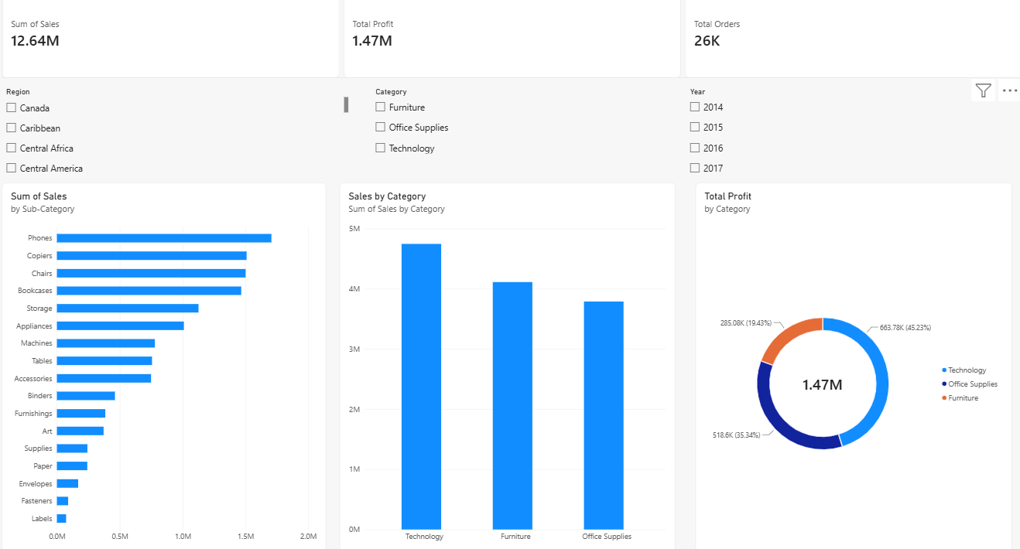

7. RESULT:
Relational and multidimensional reports were successfully generated using the star schema in Power BI. A Table visual was used for detailed transactional analysis, while a Matrix visual with Geo_Hierarchy supported geographical summarization and drill-down operations. Comparative charts were created to analyse category sales, regional profit, top customers and yearly sales trends. An interactive dashboard combining KPI cards, charts and slicers was also developed to support business analysis and informed decision-making.

8. LEARNING OUTCOMES:
- Learned to generate relational reports using transactional business data.
- Understood the creation of multidimensional reports using geographical hierarchies.
- Applied sorting, filtering, aggregation and drill-down operations in Power BI.
- Developed comparative charts to analyse sales, profit and customer performance.
- Designed an interactive dashboard using KPI cards and slicers.
- Understood how different reporting techniques support business intelligence and decision-making.

